Experiment 13
Aim
To implement the Minimax algorithm in Python for a two-player game, where the computer chooses the best possible move.
Algorithm:
- Start
- Initialize the game board.
- Define the winning conditions.
- Check whether the current player has won or the game is a draw.
- If the computer wins, return +1.
- If the human player wins, return −1.
- If the game is a draw, return 0.
- Generate all possible moves for the current player.
- For the MAX player (Computer), select the move with the highest score.
- For the MIN player (Human), select the move with the lowest score.
- Undo the move after evaluating it.
- Repeat the process recursively until the best move is found.
- Make the computer's best move.
- Check whether the game is over.
- Repeat until there is a winner or draw.
- Stop.
Code:
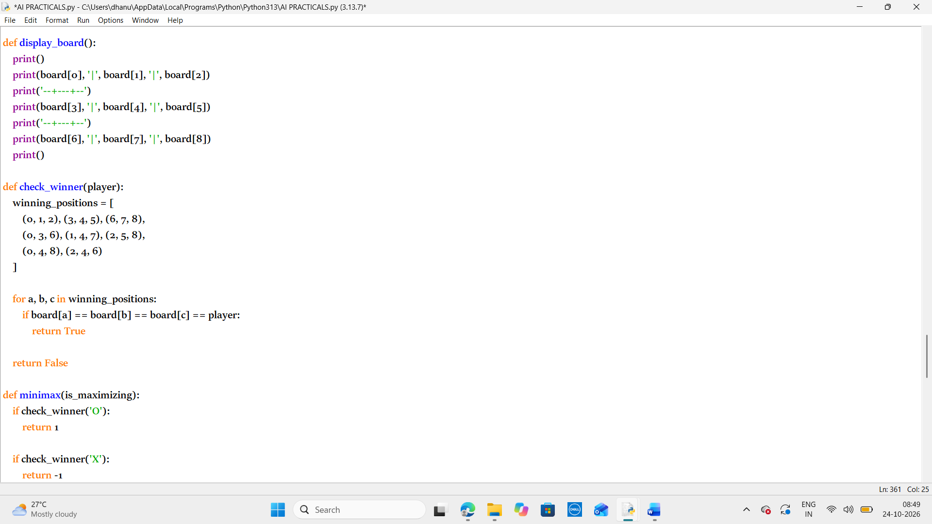
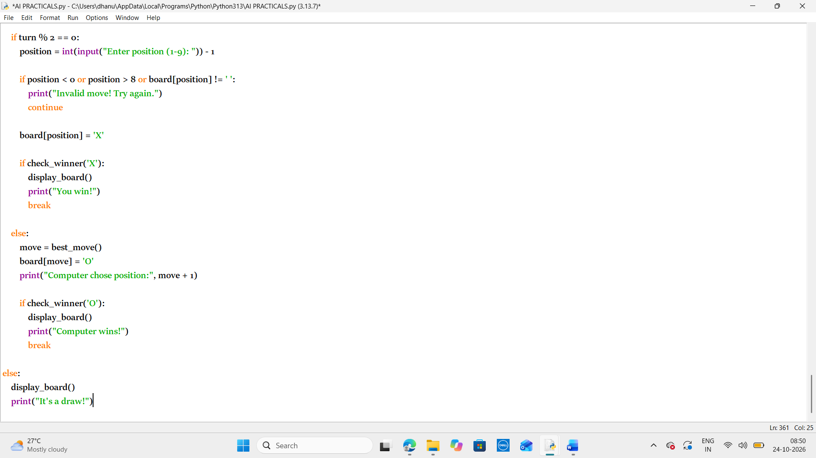
Output:
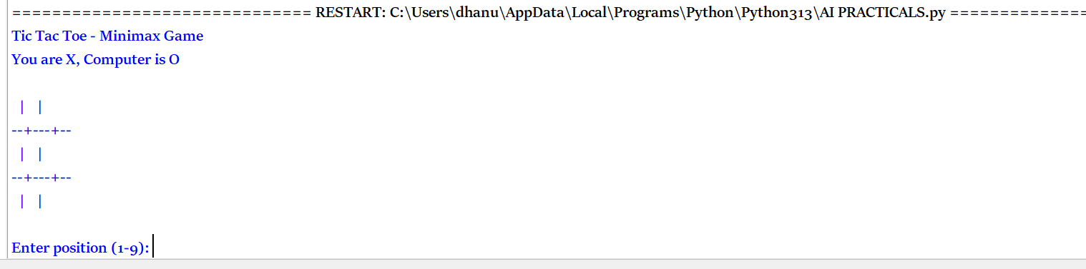
Result:
Thus the python program to implement the Minimax algorithm in Python for a two-player game, where the computer chooses the best possible move has been executes successfully.

